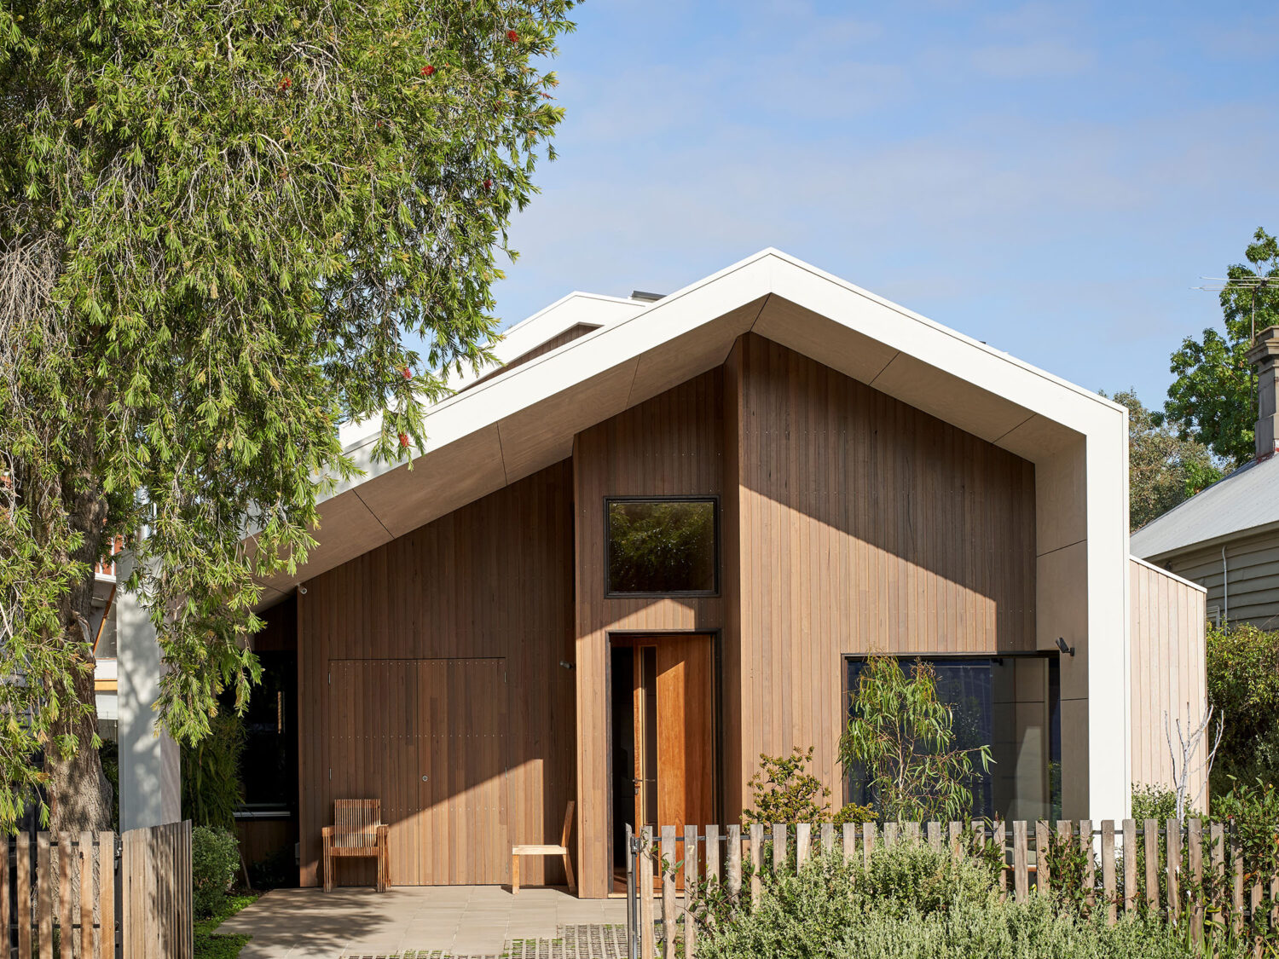
Explore the relationship between the sustainable star energy rating and the evolving building / construction industry. With reference to the case study ‘MM House Northcote’.

By Fergus Shaw (S8076165)

The introduction of the star energy rating in domestic and residential homes throughout Australia has been a major success not only in the building/construction industry, but for reducing the impact on the natural environment. The energy rating calculates on a star rating from 0-10 the energy output expelled from an existing or new household. The 6-star energy rating became a mandatory requirement in the National construction code (NCC) in 2011 and has resulted in many favourable outcomes for the Australian construction community. Recently, a 7-star energy rating has been proposed and set to take over in October 2023, the ‘MM Building Northcote’ is an outstanding representation of how this change will positively impact the industry. However, this has sparked a contentious debate within the industry about whether it is too early for this major advancement and may have critical repercussions on homeowners considering new builds.

By exploring the effects of the sustainable star energy rating, it is evident it has left a positive impact on both the environment and the building industry. The 6-star rating is based upon the thermal performance of the envelope of a building, for example, the components such as the floor, roof, and walls are taken into consideration. The results occurred from 6-star energy homes have been tremendous in improving comfortability and lowering long-term costs for owners. Look no further than the sustainable ‘MM House’ built in Northcote Victoria, on average a total of 50 litres of water is used per day by implementing features such as low-flowing taps, under deck water tanks, and a drip irrigation system. This is 100 litres less compared to the average household in Victoria. Hence, would significantly reduce water waste, reducing the number of emissions being released into the atmosphere and is a cost-effective alternative for the owners. Further expanding on the comfortability aspect, the 6-star energy rating has ensured that new dwellings achieve a far greater liveability component compared to historic buildings. By considering factors such as insulation values (R-Value), glazing of windows/doors, and reducing artificial lighting, homeowners are in turn are decreasing their reliance on heaters/air-conditioners. Hence, producing a self-sustaining, warm in winter and cold in summer environment. The insulation utilised in the Northcote ‘MM House’ reinforces the above. The passive house consists of a roof insulation value of R6.5, and both floors and walls contain a R5 value. Thru choosing these high values, it ensures the house is airtight and keeps the internal temperature consistent. Therefore, the owners are less likely to rely on high energy inefficient appliances, and positively impacting the environment. Overall, the 6-star energy rating has been a key success into increasing homeowners’ comfortability and also reducing the building industry impact on global climate change.

The introduction of the 7-star energy rating later this year, will further strengthen and positively impact the direction of the building industry on the environment. The construction industry is the 5th largest contributor to carbon emissions in Australia. The addition of 1 star required on all new dwellings in Australia, will thus increase energy efficiency, comfortability and will be more cost effective for homeowners in the long term to occupy. Quoting sustainable expert Dr Trivess Moore ‘’the performance of new Australian housing is at least 40% worse than many other developed countries in similar climate zones’’, highlights how sustainably far-off Australia is as a country and reinforces the need to increase our energy standards. The ‘MM House Northcote’ (as seen in photograph 1) is an excellent case study with an energy NatHERS rating of 7.9 stars, far greater than the NCC requirement. By investigating this case study, it emphasises how to household owners are not only living comfortably but are leaving a minimal footprint on the earth. The house regulates heating and cooling through a HRV System (Heat recovery ventilation system), which provides constant fresh air all the time, while extracting former old stale air and releasing it externally. This provides a consistent healthy environment, while also varying the house temperature to the desired degrees. Extending on the previous point, Figure 1 below shows that the MM House in August when it was recorded to be 3-4 degree outside, the house is a natural estimated 20 degrees inside without the use of heating. Hence, proving how energy efficient this house is and the effectiveness of the 7-star rating. Poorly made homes that do not achieve a high energy efficiency rating and are freezing during winter months are alleged to contribute to approximately 6% of deaths in Australia. In contrast, Sweden has half the number of fatalities caused by cold, and their winter months can reach lows of minus 30 degrees. Highlighting not only how energy advanced Sweden’s building industry is, but how having higher energy rating can ultimately reduce deaths and improve homeowners’ liveability standards. Finally, the 7-star rating although expensive to begin with, will ultimately raise the price on their property to an average of 9.4% more (according to the university of Melbourne) resulting in an incentive for owners to build, thus positively impacting the construction industry by increasing workflow and the demand of jobs.
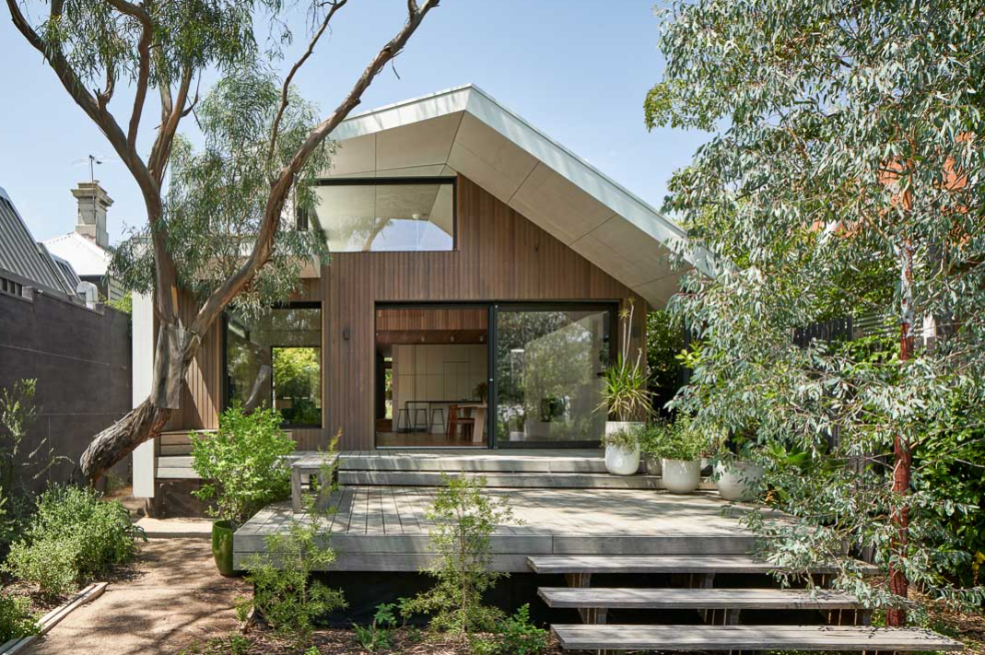
Photograph 1 – MM House Northcote design by eMe. (2019). MM House Northcote. MM House. photograph. Retrieved May 30, 2023, from https://emedesign.com.au/project/mm-house/.
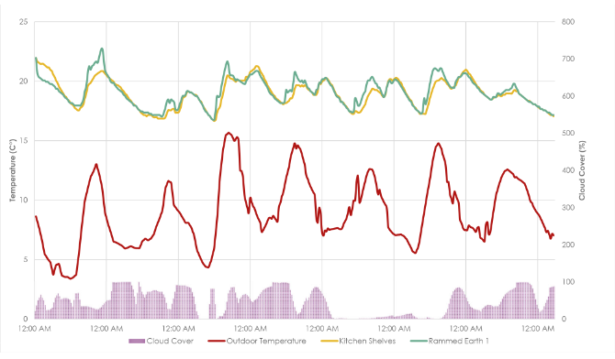
Figure 1:
Middleton, L. (n.d.). Graph showing the results of temperature sensors between 19 August - 27 August 2020 in Melbourne. YourHome. photograph, Luke Middleton, EME Design. Retrieved from https://www.yourhome.gov.au/case-studies/warm/northcote-victoria .

The repercussions of implementing the 7-star system to early may be detrimental to the survival of the building and construction industry. Although in the long term a more energy efficient house will be more cost effective, many owners simply cannot afford the costs to implement these components into their builds. The rising costs in building materials such as timber and steel have resulted in enormous building contracts for owners, along with the additional costs involved with glass glazing, insulation and installation of solar in order to achieve the 7 star rating may be near impossible for some homeowners to afford. Post covid-19, the cost of materials such as plywood and structural steel have increased by more than 25% over the past year, further supporting the fact that it is becoming too expensive to build in today’s society. By implementing the 7-star rating too soon into the industry, it may discourage owners from building their new dream homes. In turn, reducing the needs and jobs of many within the construction industry. It is important that we explore the relationship and possible negative consequences that may occur if the 7-star rating is brought into effect too early.

In conclusion, the building/construction industry must constantly evolve in order to survive and reduce the effect of climate change on the natural environment. Over the past decade the 6-star energy rating has been a major success, and has resulted in an abundance of benefits not only for the environment but for the building industry, the house ‘MM House’ is a leading model in the industry and highlights the numerous advantages of having and encouraging a 7 star or above energy rating, as it improves liveability and is cost effective in the long term. However, it is important to address that the building industry may not yet be ready for the drastic change and further investigation should be done before the star rating is increased.
REFERENCES APA 7 STYLE
Building rating tools. YourHome. (n.d.). https://www.yourhome.gov.au/buy-build-renovate/building-rating-tools
MM House. Sustainable House Day. (2021, October 13). https://sustainablehouseday.com/listing/mm-house/
MM house - passive house. EME Design. (2021, November 11). https://emedesign.com.au/project/mm-house/
Author links open overlay panel Zhengen Ren a, a, b, & AbstractIn 2019 Energy Ministers agreed the Trajectory for Low Energy Buildings (the Trajectory). One of the key aspects in the Trajectory for residential buildings is to expand Nationwide House Energy Rating Scheme (NatHERS) to offer nationally accredite. (2023, February 20). Development of a benchmark tool for whole of Home Energy Rating for Australian New Housing. Energy and Buildings. https://www.sciencedirect.com/science/article/pii/S0378778823001512
How supply and demand are affecting building cost inflation. How supply and demand are affecting building cost inflation | The National Housing Finance & Investment Corporation (NHFIC). (2022, October 4). https://www.nhfic.gov.au/research/how-supply-and-demand-are-affecting-building-cost-inflation
Sakkal, P., & Carlson, B. (2021, December 20). Builders driven to the wall as material costs go through the roof. The Age. https://www.theage.com.au/national/victoria/builders-driven-to-the-wall-as-material-costs-go-through-the-roof-20211203-p59egr.html
Seeing 7-stars: New home energy efficiency standards explained. Sustainability Victoria. (n.d.). https://www.sustainability.vic.gov.au/energy-efficiency-and-reducing-emissions/building-or-renovating/7-star-homes-program/7-star-homes-program-resources/seeing-7-stars-new-home-energy-efficiency-standards-explained
Energy. (2023, January 27). 7 Star Energy Efficiency Building Standards Common Questions. Energy. https://www.energy.vic.gov.au/for-households/7-star-energy-efficiency-building-standards/common-questions
Tents to castles: Building Energy Efficient, cost-saving Aussie Homes: Report. Climate Council. (2022, April 26). https://www.climatecouncil.org.au/resources/tents-castles-building-energy-efficient-cost-saving-aussie-homes/
YouTube. (2021). MM HOUSE Walk through. YouTube. Retrieved June 1, 2023, from https://www.youtube.com/watch?v=dXHQqx4Q-HI .

Victorian Building Authority. (2023, April 30). Energy efficiency requirements. Victorian Building Authority. https://www.vba.vic.gov.au/consumers/home-renovation-essentials/energy-efficient-requirements
Quote from expert Dr Trivess Moore . (n.d.). https://www.climatecouncil.org.au/wp-content/uploads/2022/04/CC_Final_Tents-Castles_Low_Res_Single2.pdf
design by eMe. (2019). MM House Northcote. MM House. photograph. Retrieved May 30, 2023, from https://emedesign.com.au/project/mm-house/ .
Middleton, L. (n.d.). Graph showing the results of temperature sensors between 19 August - 27 August 2020 in Melbourne. YourHome. photograph, Luke Middleton, EME Design. Retrieved from https://www.yourhome.gov.au/case-studies/warm/northcote-victoria .

